Vaibhav Shikshan Sanstha

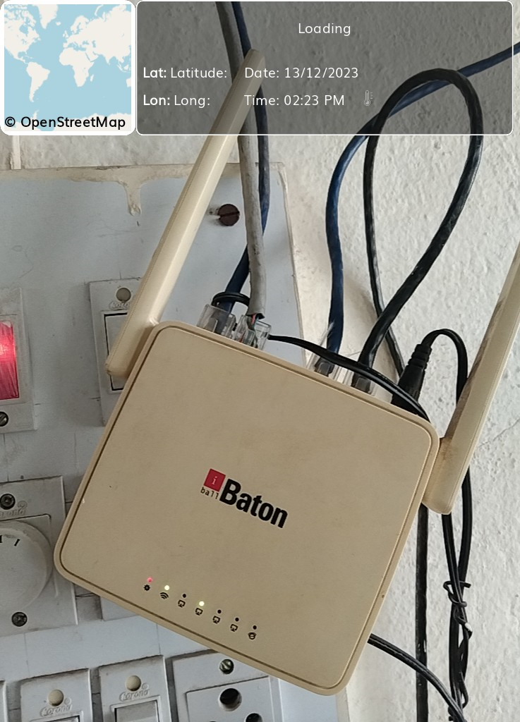 **College of Education (B. Ed), Vita**

Internet Connection